Name: Hammad Ahmed Awan

BSCS-VII, Sec ‘A’

Sumiitted to: Sir Nisar Ahmed Siddiqque

Mobile Application Development Lab No.1

**TASK 1 :**

**Code :**

**package com.example.lab1activities  
  
import android.content.Intent  
import android.support.v7.app.AppCompatActivity  
import android.os.Bundle  
import android.view.View  
import android.widget.Button  
import android.widget.TextView  
import kotlin.random.Random  
  
class MainActivity : AppCompatActivity() {  
 override fun onCreate(savedInstanceState: Bundle?) {  
 super.onCreate(savedInstanceState)  
 setContentView(R.layout.*activity_main*)  
  
 var num = Random.nextInt(100)  
 var txt = findViewById<TextView>(R.id.*textView1*)  
 var tf = findViewById<TextView>(R.id.*editTextTextPersonName*)  
 var btn = findViewById<Button>(R.id.*button*)  
 var btn1 = findViewById<Button>(R.id.*button2*)  
  
 btn.setOnClickListener(View.OnClickListener {  
  
 if(tf.*text*.toString().*toInt*() < num){  
 txt.*text* = "Your Guess Number Is Less"  
 }  
 else if(tf.*text*.toString().*toInt*() > num)  
 {  
 txt.*text* = "Your Guess Number Is high"  
  
 }  
 else  
 {  
 txt.*text* = "Your Guess is Correct"  
  
 }  
 })  
 btn1.setOnClickListener(View.OnClickListener {  
 clickMe()  
 })  
 }  
 fun clickMe()  
 {  
 val intent = Intent(this, MainActivity2::class.*java*)  
 startActivity(intent)  
  
 }  
  
}**

**Output Screenshots:**

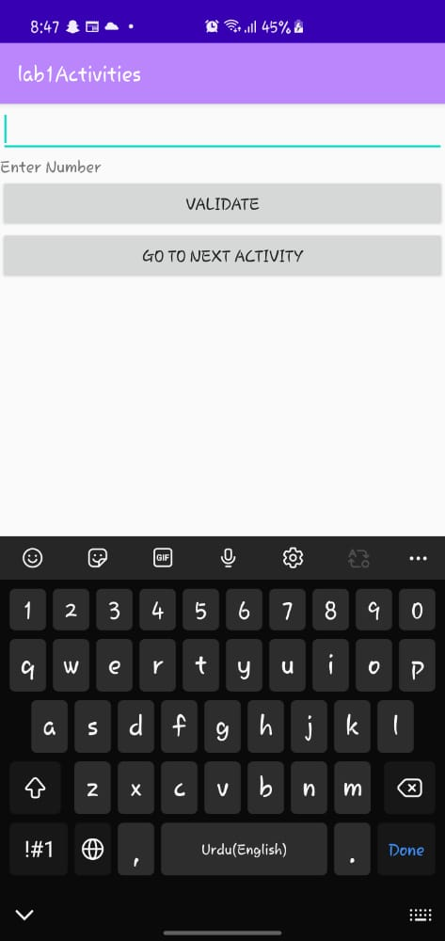

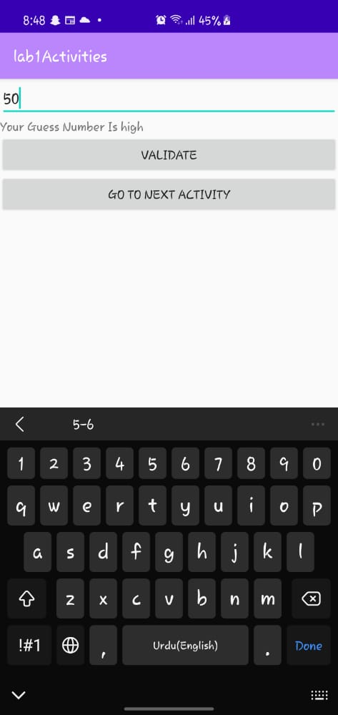

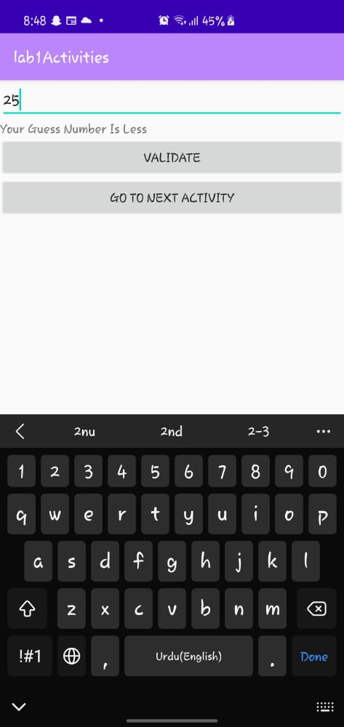

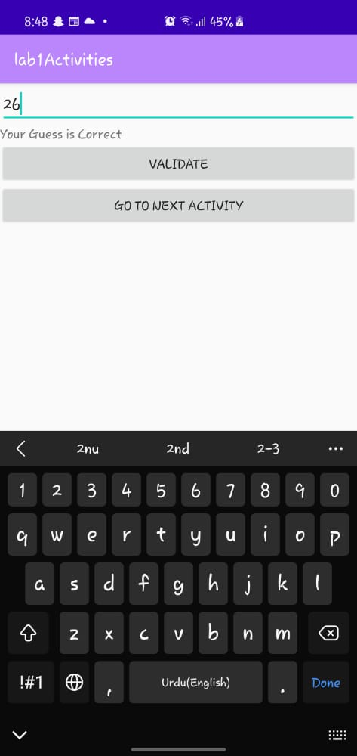

**Task 2:**

**package com.example.lab1activities  
  
import android.content.Intent  
import android.support.v7.app.AppCompatActivity  
import android.os.Bundle  
import android.os.Handler  
import android.os.Looper  
import android.view.View  
import android.widget.Button  
import android.widget.ImageView  
  
class MainActivity2 : AppCompatActivity() {  
 override fun onCreate(savedInstanceState: Bundle?) {  
 super.onCreate(savedInstanceState)  
 setContentView(R.layout.*activity_main2*)  
 var bool = true ;  
 var imgs = ArrayList<ImageView>() ;  
 fun checking(imv: ImageView){  
 if(bool){  
 bool = false ;  
 imgs.add(imv);  
 }else{  
 imgs.add(imv);  
 if(imgs[0].getTag()==imgs[1].getTag()){  
 imgs[0].setImageResource(R.drawable.*good*)  
 imgs[1].setImageResource(R.drawable.*good*)  
 imgs[0].*isClickable* = false ;  
 imgs[1].*isClickable* = false ;  
 }else{  
 imgs[0].setImageResource(R.drawable.*empty*)  
 imgs[1].setImageResource(R.drawable.*empty*)  
 }  
 bool = true ;  
 imgs = ArrayList<ImageView>();  
 }  
 }  
 fun check(imv: ImageView){  
 Handler(Looper.getMainLooper()).postDelayed(  
 {  
 checking(imv);  
 },  
 1000  
 )  
 }  
 var tile1 = findViewById<ImageView>(R.id.*imageView1*) ;  
 var tile2 = findViewById<ImageView>(R.id.*imageView2*) ;  
 var tile3 = findViewById<ImageView>(R.id.*imageView3*) ;  
 var tile4 = findViewById<ImageView>(R.id.*imageView4*) ;  
 var tile5 = findViewById<ImageView>(R.id.*imageView5*) ;  
 var tile6 = findViewById<ImageView>(R.id.*imageView6*) ;  
 var tile7 = findViewById<ImageView>(R.id.*imageView7*) ;  
 var tile8 = findViewById<ImageView>(R.id.*imageView8*) ;  
 var tile9 = findViewById<ImageView>(R.id.*imageView9*) ;  
 var tile10 = findViewById<ImageView>(R.id.*imageView10*) ;  
 var tile11 = findViewById<ImageView>(R.id.*imageView11*) ;  
 var tile12 = findViewById<ImageView>(R.id.*imageView12*) ;  
 var tile13 = findViewById<ImageView>(R.id.*imageView13*) ;  
 var tile14 = findViewById<ImageView>(R.id.*imageView14*) ;  
 var tile15 = findViewById<ImageView>(R.id.*imageView15*) ;  
 var tile16 = findViewById<ImageView>(R.id.*imageView16*) ;  
 var tile17 = findViewById<ImageView>(R.id.*imageView17*) ;  
 var tile18 = findViewById<ImageView>(R.id.*imageView18*) ;  
 var tile19 = findViewById<ImageView>(R.id.*imageView19*) ;  
 var tile20 = findViewById<ImageView>(R.id.*imageView20*) ;  
 var tile21 = findViewById<ImageView>(R.id.*imageView21*) ;  
 var tile22 = findViewById<ImageView>(R.id.*imageView22*) ;  
 var tile23 = findViewById<ImageView>(R.id.*imageView23*) ;  
 var tile24 = findViewById<ImageView>(R.id.*imageView24*) ;  
 tile1.setOnClickListener(View.OnClickListener {tile1.setTag("ball");tile1.setImageResource(R.drawable.*ball*);check(tile1);})  
 tile2.setOnClickListener(View.OnClickListener {tile2.setTag("badminton");tile2.setImageResource(R.drawable.*badminton*);check(tile2);} )  
 tile3.setOnClickListener(View.OnClickListener {tile3.setTag("bullseye");tile3.setImageResource(R.drawable.*bullseye*) ;check(tile3);} )  
 tile4.setOnClickListener(View.OnClickListener {tile4.setTag("badminton");tile4.setImageResource(R.drawable.*badminton*) ;check(tile4);} )  
 tile5.setOnClickListener(View.OnClickListener {tile5.setTag("tree");tile5.setImageResource(R.drawable.*tree*) ;check(tile5);} )  
 tile6.setOnClickListener(View.OnClickListener {tile6.setTag("tree");tile6.setImageResource(R.drawable.*tree*) ;check(tile6);} )  
 tile7.setOnClickListener(View.OnClickListener {tile7.setTag("bullseye");tile7.setImageResource(R.drawable.*bullseye*) ;check(tile7);} )  
 tile8.setOnClickListener(View.OnClickListener {tile8.setTag("ball");tile8.setImageResource(R.drawable.*ball*) ;check(tile8);} )  
 tile9.setOnClickListener(View.OnClickListener {tile9.setTag("game");tile9.setImageResource(R.drawable.*game*) ;check(tile9);} )  
 tile10.setOnClickListener(View.OnClickListener {tile10.setTag("bat");tile10.setImageResource(R.drawable.*bat*) ;check(tile10);} )  
 tile11.setOnClickListener(View.OnClickListener {tile11.setTag("bat");tile11.setImageResource(R.drawable.*bat*) ;check(tile11);} )  
 tile12.setOnClickListener(View.OnClickListener {tile12.setTag("game");tile12.setImageResource(R.drawable.*game*) ;check(tile12);} )  
 tile13.setOnClickListener(View.OnClickListener {tile13.setTag("beachumbrella");tile13.setImageResource(R.drawable.*beachumbrella*) ;check(tile13);} )  
 tile14.setOnClickListener(View.OnClickListener {tile14.setTag("kite");tile14.setImageResource(R.drawable.*kite*) ;check(tile14);} )  
 tile15.setOnClickListener(View.OnClickListener {tile15.setTag("beachumbrella");tile15.setImageResource(R.drawable.*beachumbrella*) ;check(tile15);} )  
 tile16.setOnClickListener(View.OnClickListener {tile16.setTag("lemonjuice");tile16.setImageResource(R.drawable.*lemonjuice*) ;check(tile16);} )  
 tile17.setOnClickListener(View.OnClickListener {tile17.setTag("kite");tile17.setImageResource(R.drawable.*kite*) ;check(tile17);} )  
 tile18.setOnClickListener(View.OnClickListener {tile18.setTag("popsicle");tile18.setImageResource(R.drawable.*popsicle*) ;check(tile18);} )  
 tile19.setOnClickListener(View.OnClickListener {tile19.setTag("lighthouse");tile19.setImageResource(R.drawable.*lighthouse*) ;check(tile19);} )  
 tile20.setOnClickListener(View.OnClickListener {tile20.setTag("sandcastle");tile20.setImageResource(R.drawable.*sandcastle*) ;check(tile20);} )  
 tile21.setOnClickListener(View.OnClickListener {tile21.setTag("lemonjuice");tile21.setImageResource(R.drawable.*lemonjuice*) ;check(tile21);} )  
 tile22.setOnClickListener(View.OnClickListener {tile22.setTag("sandcastle");tile22.setImageResource(R.drawable.*sandcastle*) ;check(tile22);} )  
 tile23.setOnClickListener(View.OnClickListener {tile23.setTag("popsicle");tile23.setImageResource(R.drawable.*popsicle*) ;check(tile23);} )  
 tile24.setOnClickListener(View.OnClickListener {tile24.setTag("lighthouse");tile24.setImageResource(R.drawable.*lighthouse*) ;check(tile24);} )  
  
 val btn = findViewById<Button>(R.id.*button1*)  
 btn.setOnClickListener(View.OnClickListener {  
 val intent = Intent( this, MainActivity3::class.*java*)  
 startActivity(intent)  
 })  
 }  
}**

**Output Screenshots :**

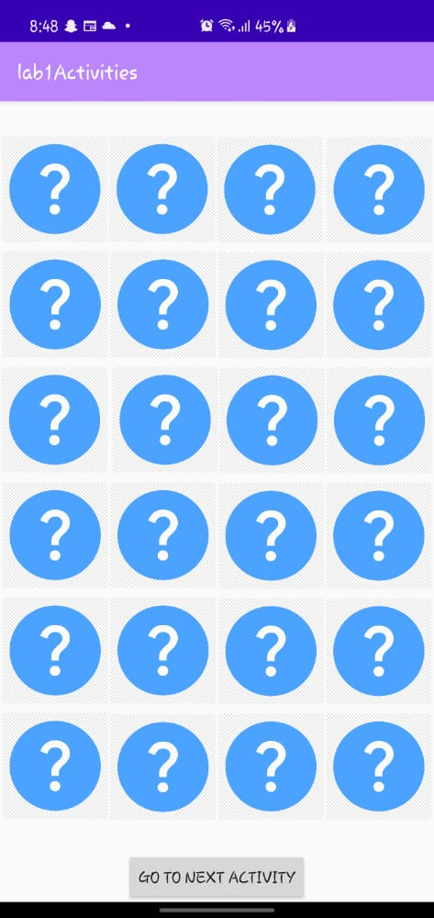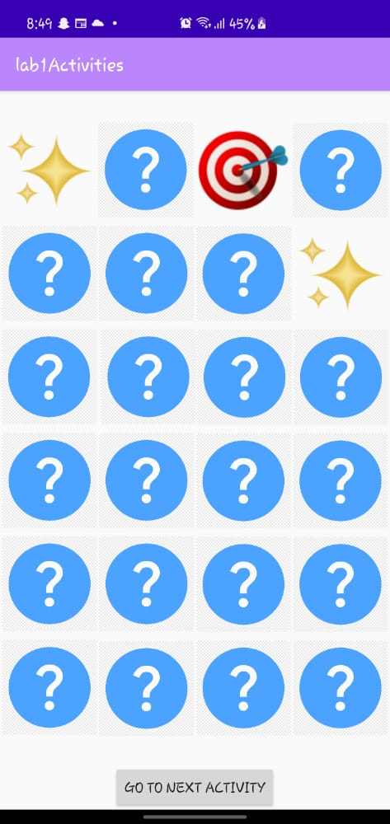

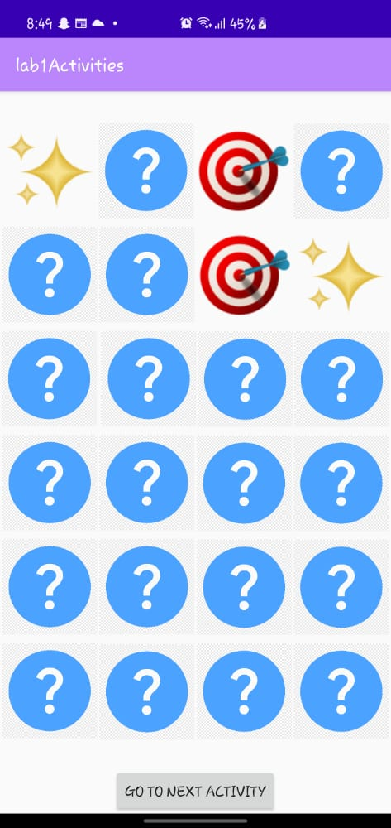

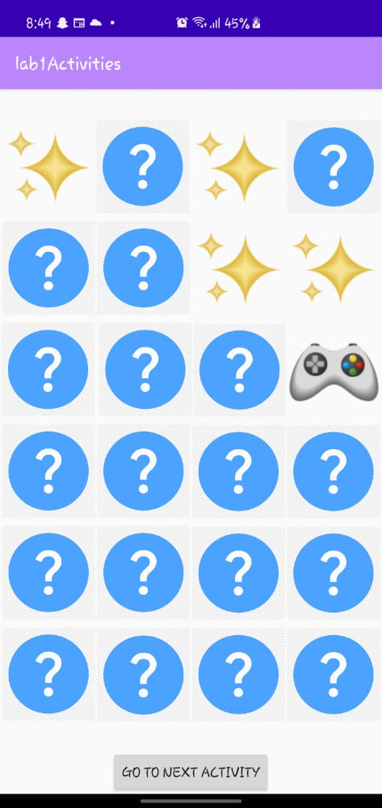

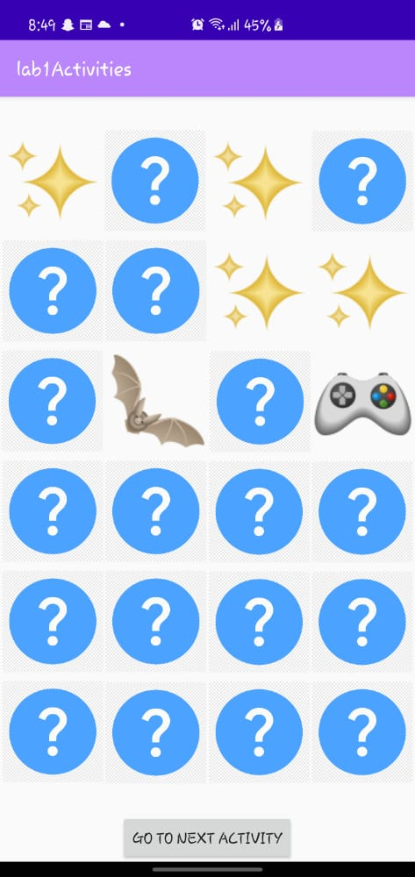

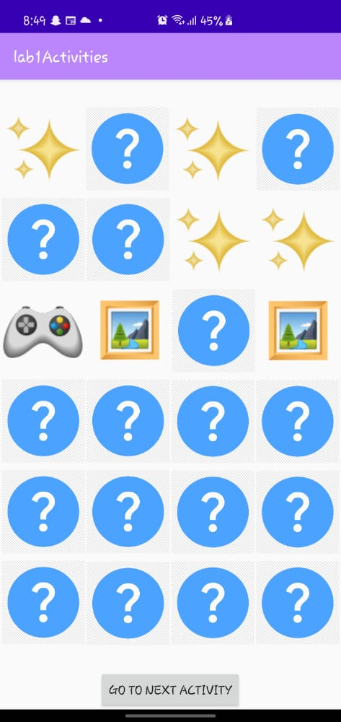

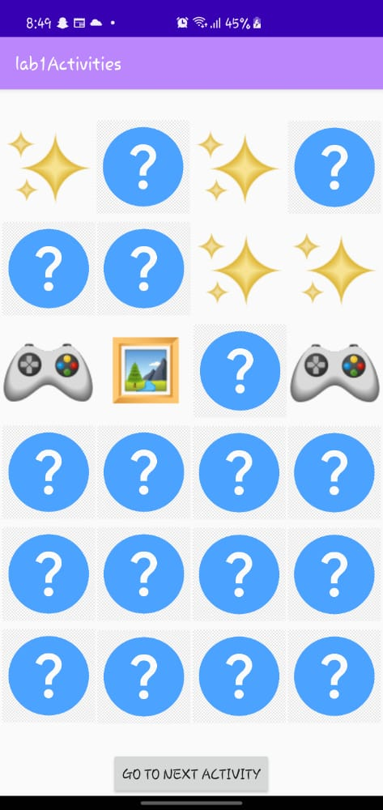

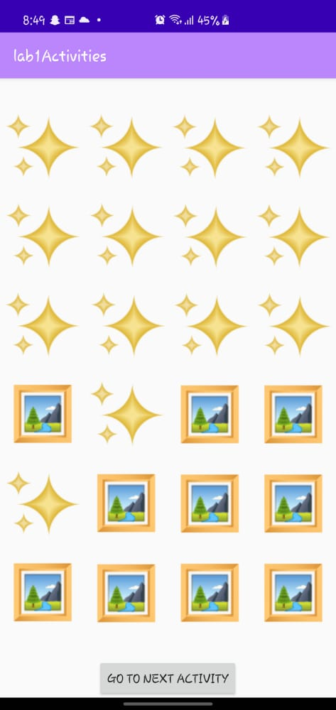



**Task 3 :**

**Code:**

**package com.example.lab1activities  
  
import android.support.v7.app.AppCompatActivity  
import android.os.Bundle  
import android.view.View  
import android.widget.CheckBox  
import android.widget.ImageView  
  
class MainActivity3 : AppCompatActivity() {  
 override fun onCreate(savedInstanceState: Bundle?) {  
 super.onCreate(savedInstanceState)  
 setContentView(R.layout.*activity_main3*)  
  
 val body = findViewById<ImageView>(R.id.*imageView27*)  
 val eye = findViewById<ImageView>(R.id.*imageView28*)  
 val hat = findViewById<ImageView>(R.id.*imageView29*)  
 val eyebrow = findViewById<ImageView>(R.id.*imageView30*)  
 val glasses = findViewById<ImageView>(R.id.*imageView31*)  
 val hand = findViewById<ImageView>(R.id.*imageView32*)  
 val ear = findViewById<ImageView>(R.id.*imageView33*)  
 val nose = findViewById<ImageView>(R.id.*imageView34*)  
 val mouth = findViewById<ImageView>(R.id.*imageView36*)  
 val most = findViewById<ImageView>(R.id.*imageView37*)  
 val foot = findViewById<ImageView>(R.id.*imageView38*)  
  
 val check1 = findViewById<CheckBox>(R.id.*checkBox*)  
 val check2 = findViewById<CheckBox>(R.id.*checkBox2*)  
 val check3 = findViewById<CheckBox>(R.id.*checkBox3*)  
 val check4 = findViewById<CheckBox>(R.id.*checkBox4*)  
 val check5 = findViewById<CheckBox>(R.id.*checkBox5*)  
 val check6 = findViewById<CheckBox>(R.id.*checkBox6*)  
 val check7 = findViewById<CheckBox>(R.id.*checkBox7*)  
 val check8 = findViewById<CheckBox>(R.id.*checkBox8*)  
 val check9 = findViewById<CheckBox>(R.id.*checkBox9*)  
 val check10 = findViewById<CheckBox>(R.id.*checkBox10*)  
  
  
 fun Add(img: ImageView){  
 if (img.*visibility*== View.*INVISIBLE*){  
 img.*visibility* = View.*VISIBLE* }else{  
 img.*visibility* = View.*INVISIBLE* }  
 }  
 check1.setOnClickListener(View.OnClickListener { Add(eye) })  
 check2.setOnClickListener(View.OnClickListener { Add(hat) })  
 check3.setOnClickListener(View.OnClickListener { Add(eyebrow) })  
 check4.setOnClickListener(View.OnClickListener { Add(glasses) })  
 check5.setOnClickListener(View.OnClickListener { Add(hand) })  
 check6.setOnClickListener(View.OnClickListener { Add(ear) })  
 check7.setOnClickListener(View.OnClickListener { Add(nose) })  
 check8.setOnClickListener(View.OnClickListener { Add(mouth) })  
 check9.setOnClickListener(View.OnClickListener { Add(most) })  
 check10.setOnClickListener(View.OnClickListener { Add(foot) })  
 }  
}**

**Output Screenshots:**

